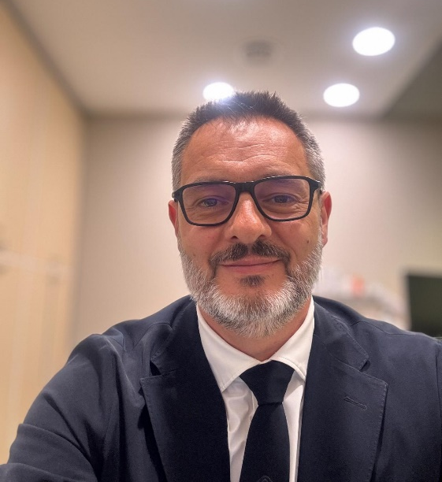
Xavier Valle, MD, MS, PhD
Sport Physician

Education
- PhD, MLG-R: A New Muscle Injury Classification
Universitat Autònoma de Barcelona, 2023
International Mention, CUM LAUDE, Extraordinary Doctorate Awards
- MSc, Investigation in Clinical Sciences
University of Barcelona, 2010-2011
- MSc, Physical Activity and Sports Performance
University of Baleares, 1999
- MD, Medicine and Surgery
Universitat Rovira i Virgili, 1989-1996

Professional Experience
- Sport Physician / Ultrasound Expert
ICATME-DEXEUS, Since May 2021
Focus: Musculoskeletal injuries diagnosis and rehabilitation.
- Team Doctor
FC Barcelona, 2004-2024
Involved in various professional sports teams including basketball, roller hockey, and football.
- Assistant Professor
Sports Medicine School, University of Barcelona, 2004-2017
Lectured on sports medicine topics and coordinated educational programs.
- Consultant
Sports and Exercise Medicine, EMEFiE del Hospital Clínic, University of Barcelona, 2001-2004
- Previous Medical Roles
National Teams and Clubs: Medical services for Spanish Volleyball Team, Taekwondo Federation, and Catalan Wrestling Team.

Skills and Expertise
- Comprehensive experience in muscle, tendon, and ligament injuries
- Proficiency in musculoskeletal ultrasound and invasive procedures
- Strong knowledge in sports performance, injury prevention, and rehabilitation strategies

Affiliations
- Former Chair and Board Member, ECOSEP (European College of Sports and Exercise Physicians)
- Vice-President, AEMEF (Spanish Society of Football Team Doctors)
- Member, BASEM, FEMEDE, SCME, and Sports Medical Council COMB

Awards
- Award for Best Publication, Ramon Balius i Juli, 2018
- Academic Scholarship, MSc in Physical Activity and Sports Performance

Publications
https://pubmed.ncbi.nlm.nih.gov/?term=Valle%2C+Xavier%5BAuthor%5D&sort=date

Languages
- English: Fluent
- Spanish & Catalan: Native
- French: Advanced (currently requires refresh)
- German: Basic medical terminology

