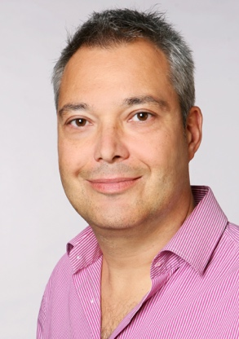
Volker Scheer, MD, PhD, MRCGP, MECOSEP
Sports and Exercise Medicine Doctor and General Practitioner
Volker qualified in medicine from the university of Munich. He trained as a general practitioner in the UK and worked for several years in Edinburgh before qualifying as a sports and exercise medicine physician at the Olympic Training Centre at the University of Heidelberg., Germany. He obtained his PhD in sports and exercise medicine at the university of Paderborn, Germany, where he led the exercise physiology department and lectured in sports medicine and physiology. He is associated professor at the Universidad a Distancia de Madrid (UDIMA), Spain and his research interest is in endurance sports and extreme medicine, examining the impact of exercise and performance on the human body. He is associate editor for Frontiers in Physiology.
He is founding member of the Ultra Sports Science Foundation. His clinical work as a Sports and Exercise Medicine doctor includes working for the DP World Professional Golf Tour, the British Armed Forces, Consultant for Dokever and UTMB, and in private practice. He has been involved in many national and international professional sporting events, including Olympic Games in Rio de Janeiro 2016, Commonwealth Games, World and European Athletic Championships and he has looked after many elite and amateur athletes. He is board member of the European College of Sports and Exercise Physicians and the ITRA medical commission.
In his youth he was a competitive sprinter at national level and he now enjoys running at a more leisurely pace up to ultramarathon distances.

